Create an AI-generated CO-PO mapping and Bloom’s taxonomy table for your own course/unit.

**Step 1: Open ChatGPT**

* Go to 👉 <https://chat.openai.com>
* Log in with your OpenAI account (Google, Microsoft, or Email login).

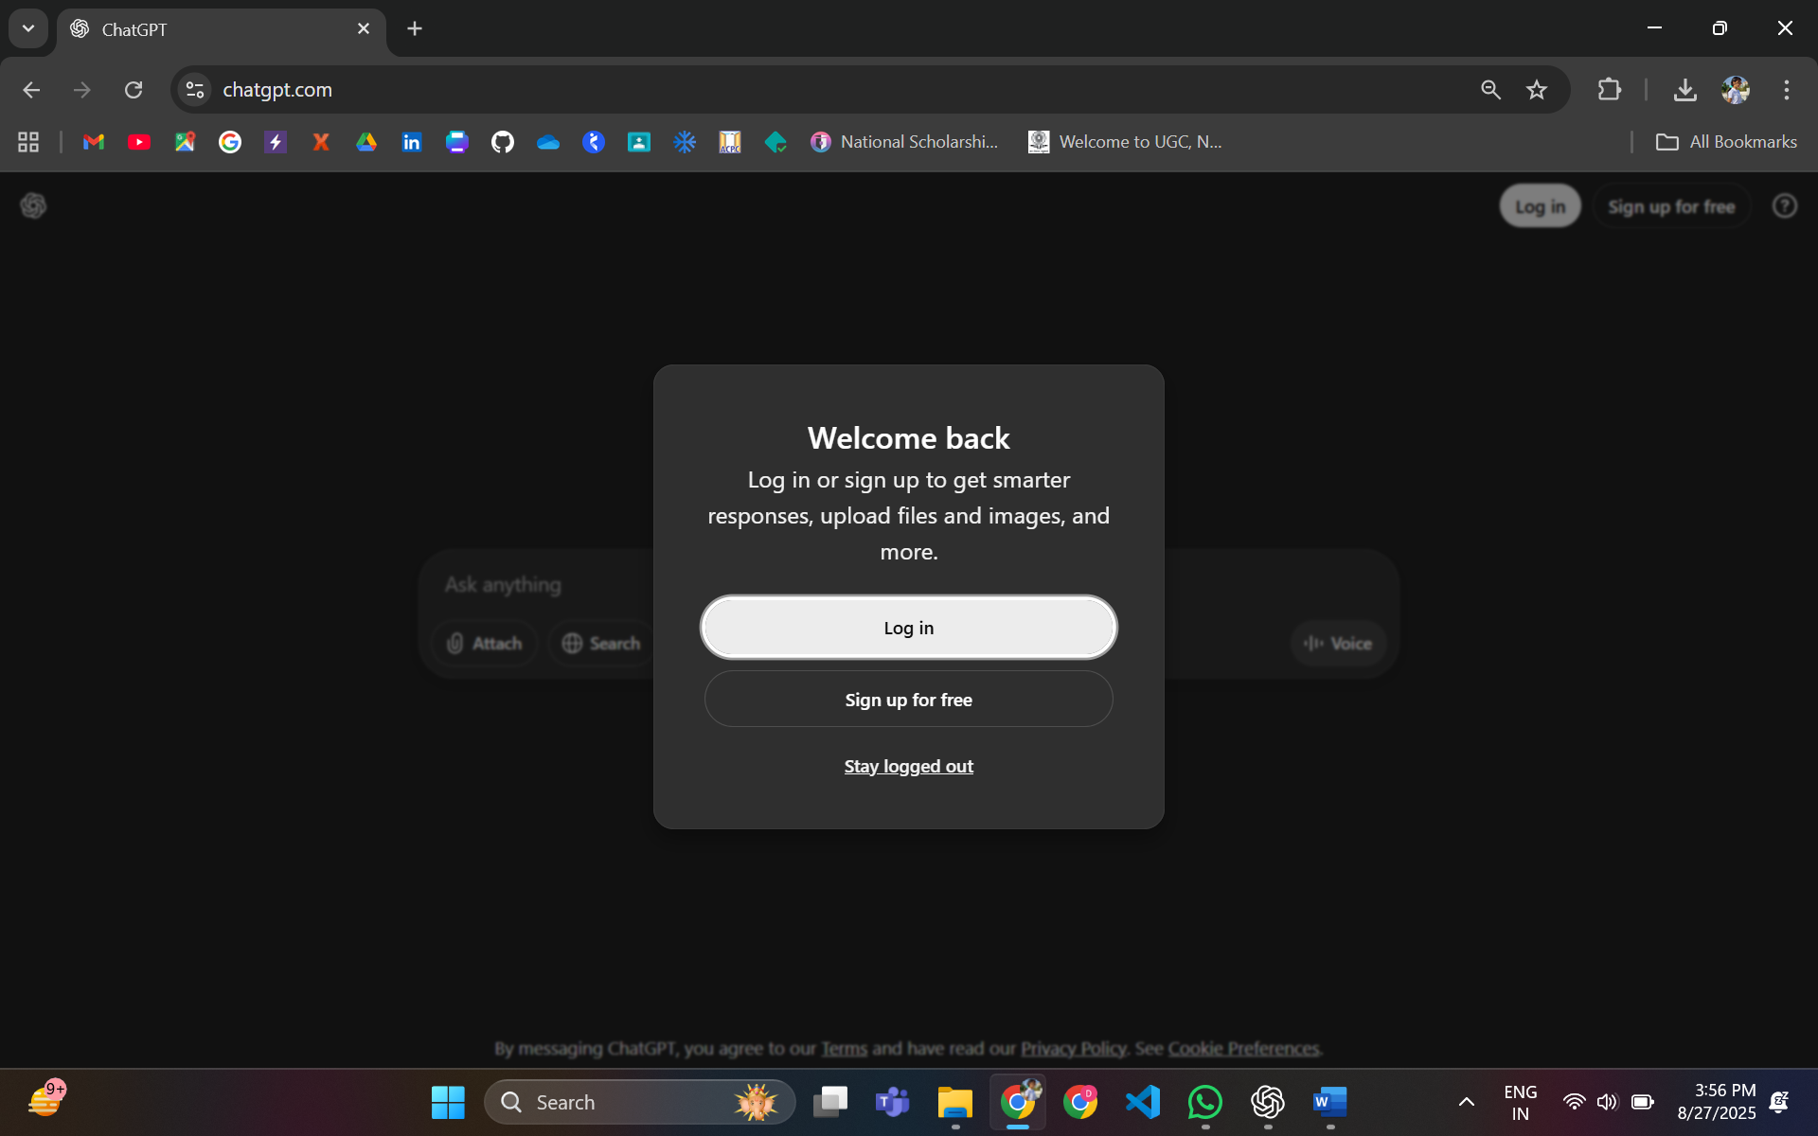

**Step 2: Navigate to the GPTs Section**

* On the left sidebar, scroll down.
* Click on “Explore GPTs” (or “GPTs” button).

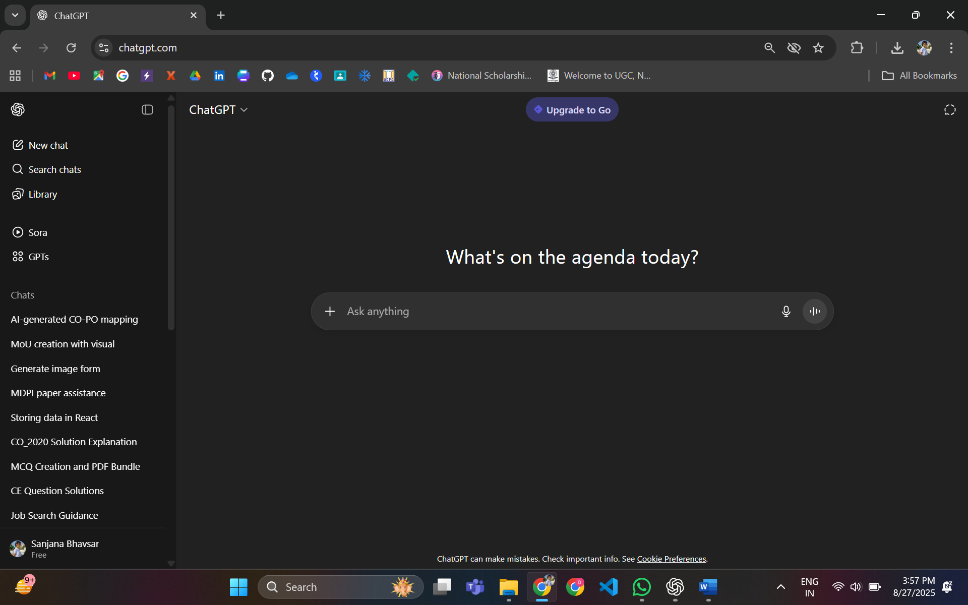

**Step 3: Search for “NAAC Guidebot”**

* In the GPTs search bar, type “NAAC Guidebot”.
* You will see a list of GPTs related to NAAC.
* Select NAAC Guidebot.

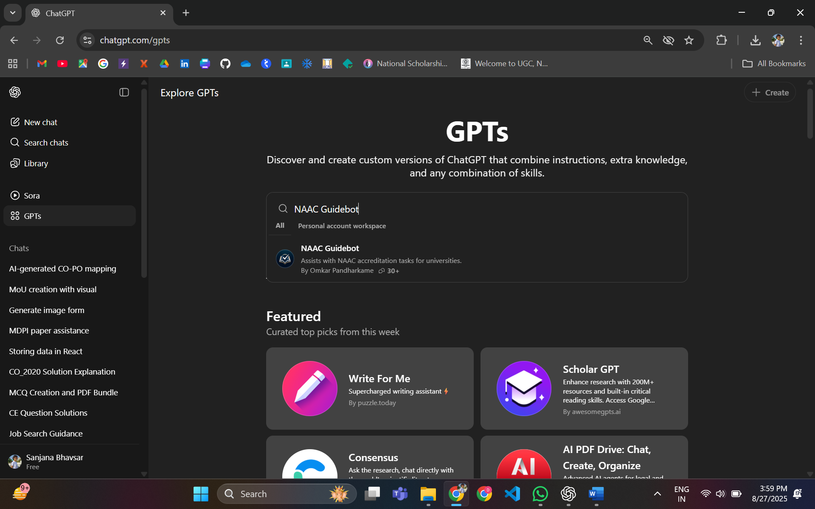

**Step 4: Open the Guidebot**

* Click on the GPT card.
* The NAAC Guidebot page will open.
* Hit “Use” / “Start Chat”.

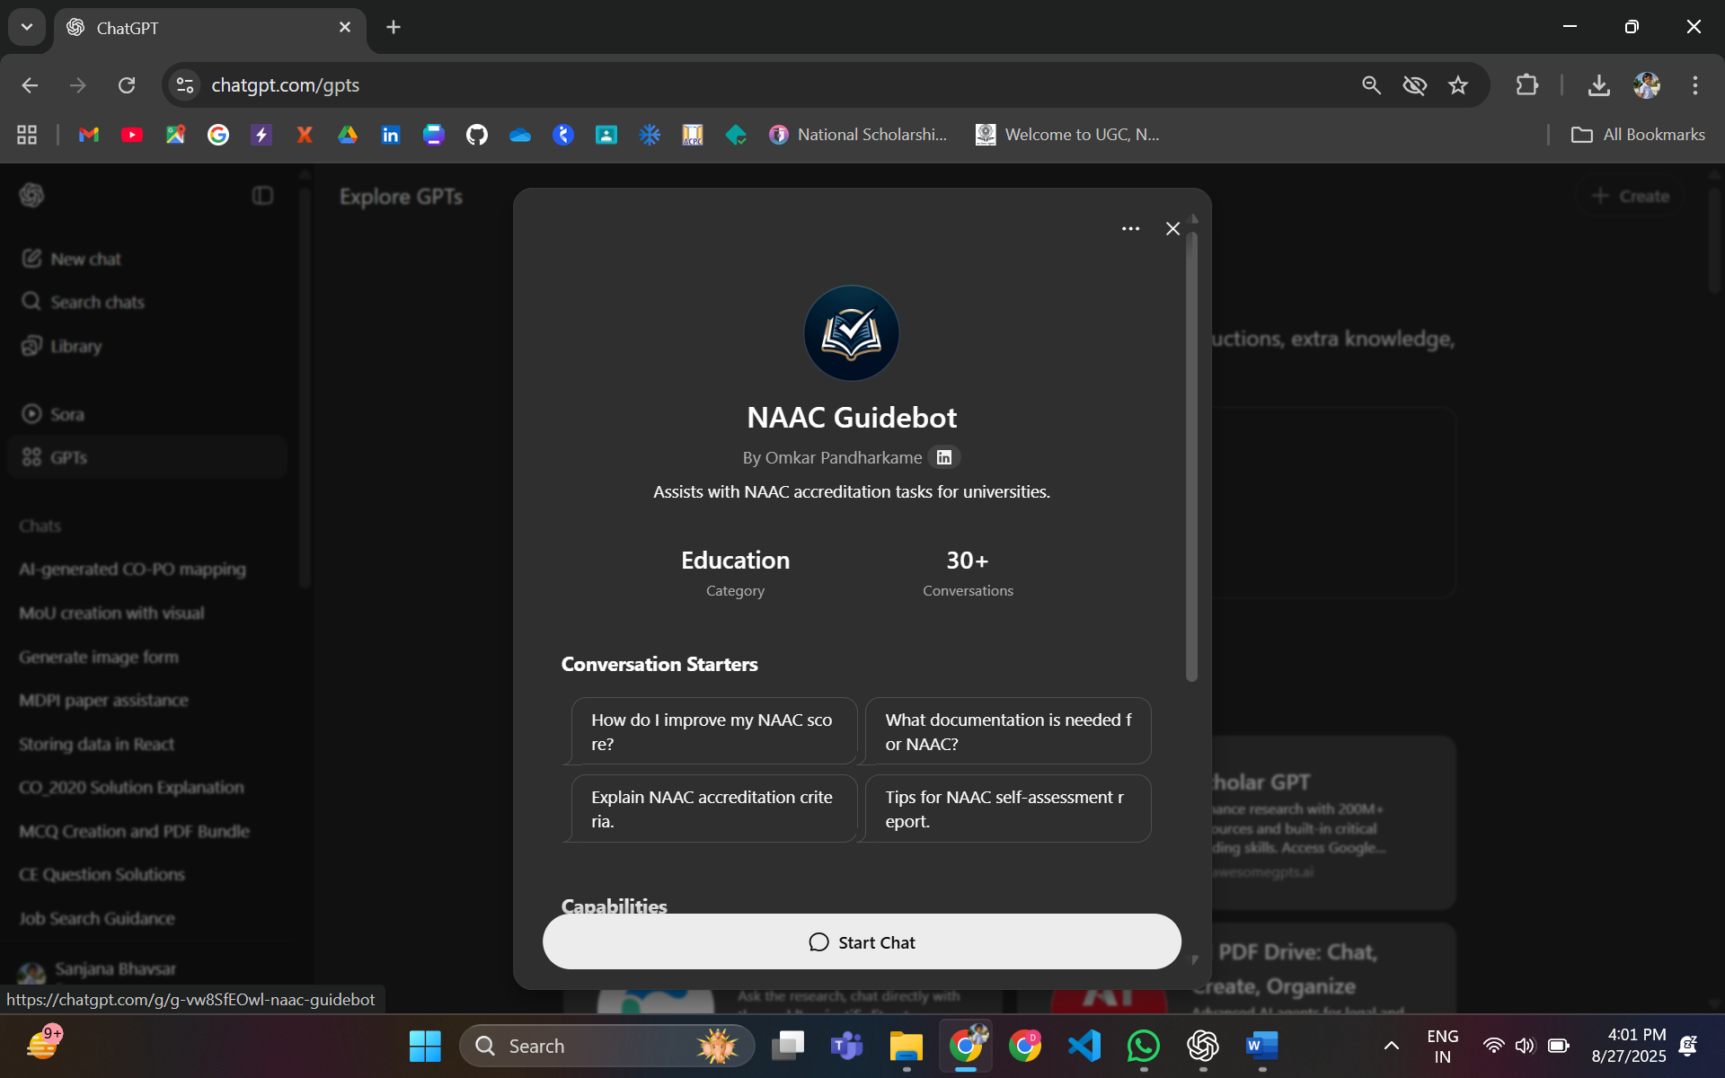

**Step 5: Start Prompting**

* In the chat box, type your query**.**

**Example:**

***“*****Create an AI-generated CO-PO mapping and Bloom’s taxonomy table for your own course/unit*.”***

* The bot will respond with tailored guidance.

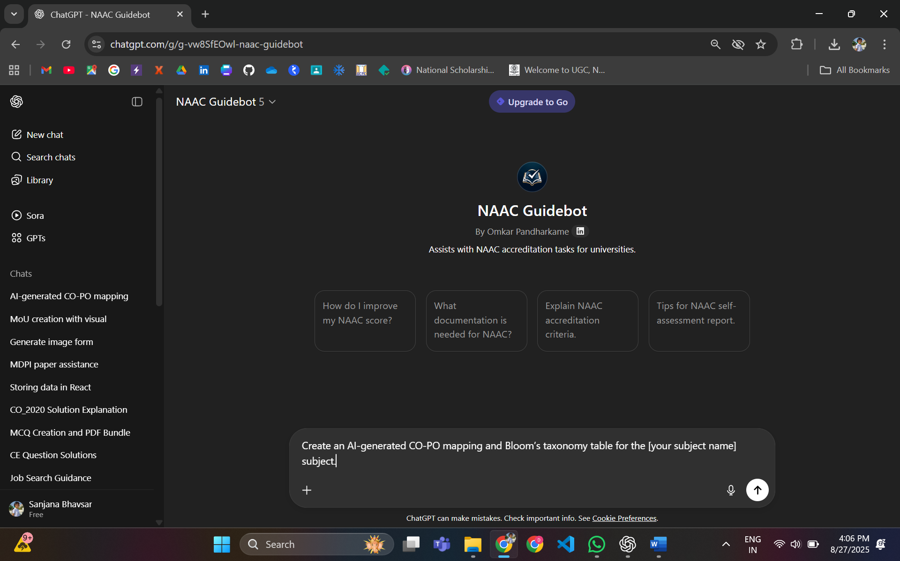

* That’s it! You are now chatting with a personalized GPT that is focused on NAAC accreditation guidance.